CODE #01

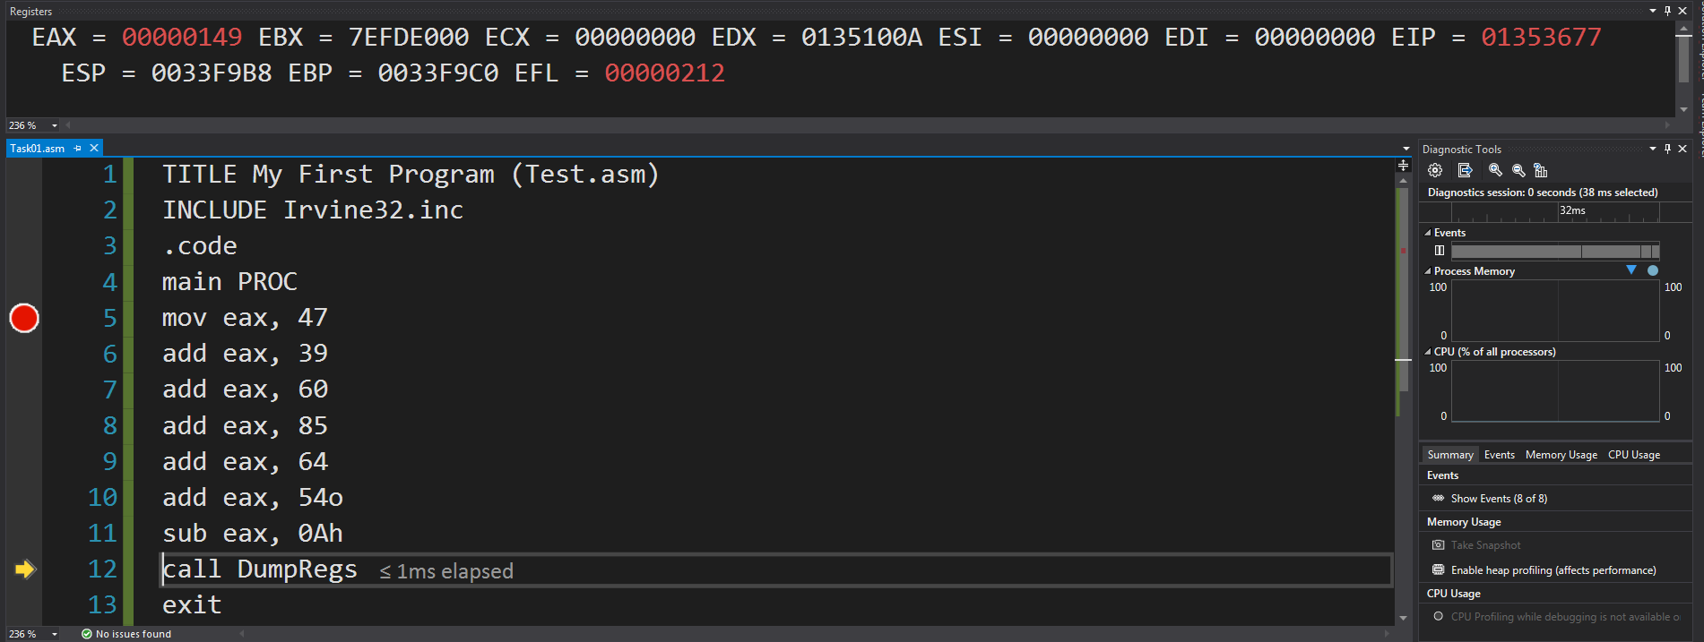DUBUG:

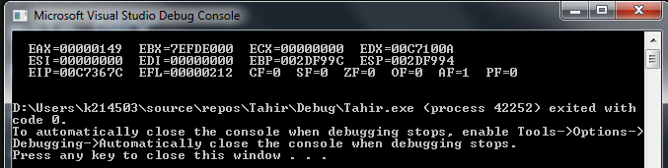OUTPUT:

CODE#02

DEBUG

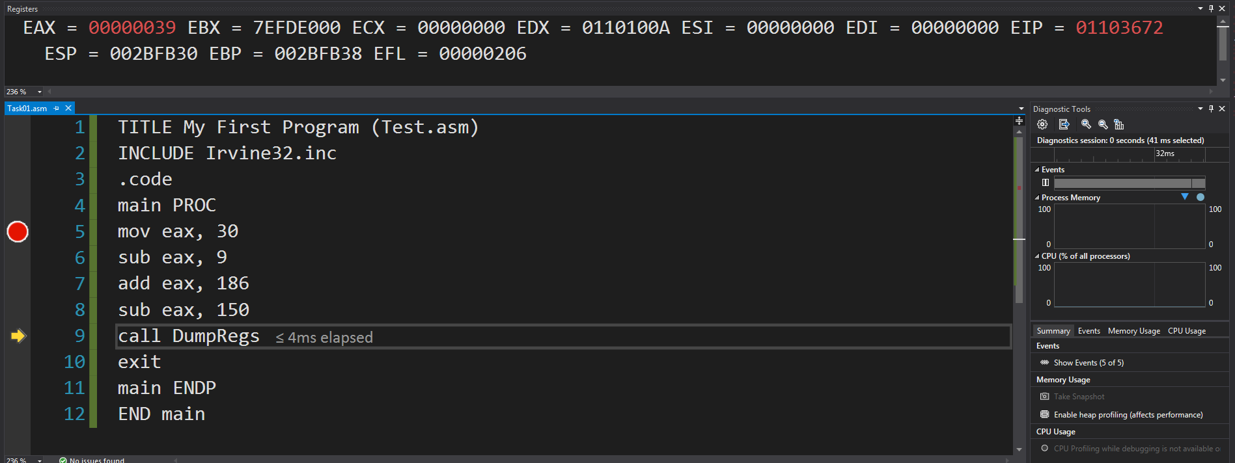

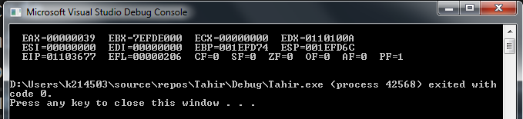OUTPUT

CODE#03

DEBUG

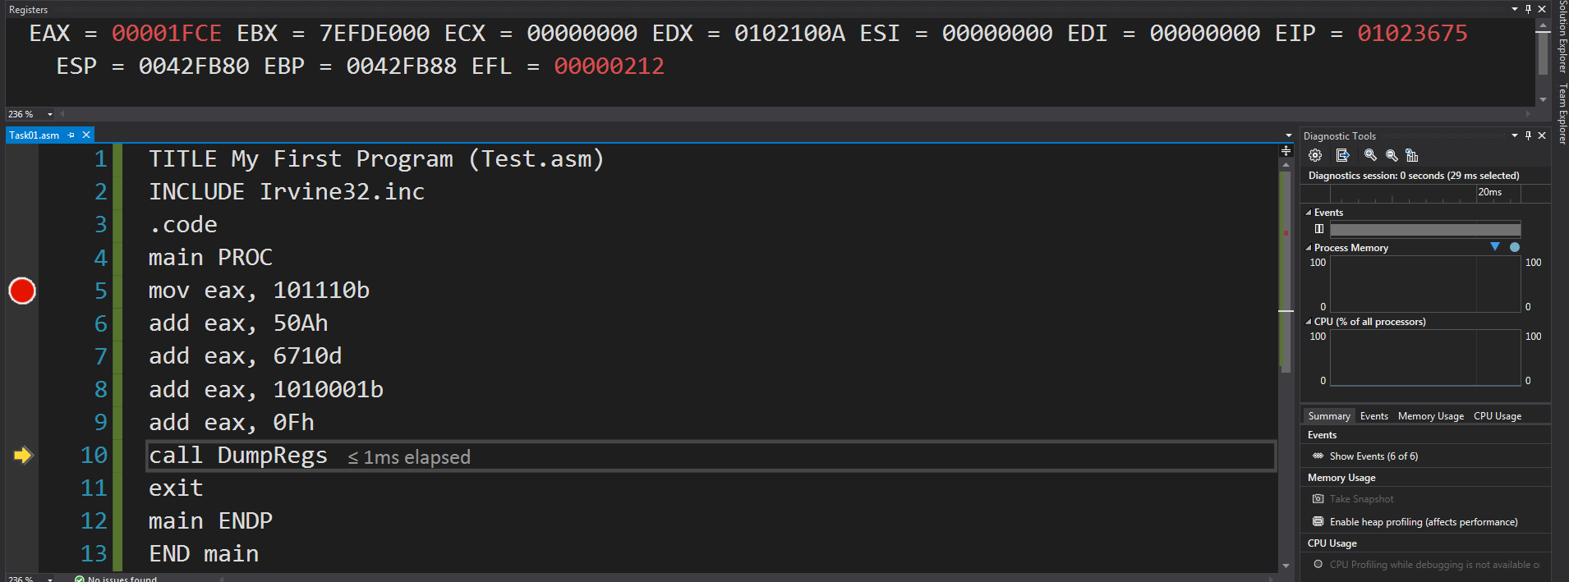

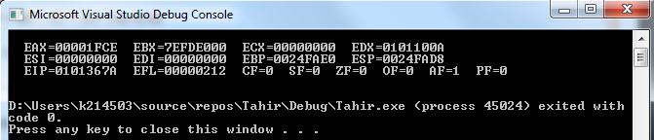OUTPUT

CODE#04

DEBUG

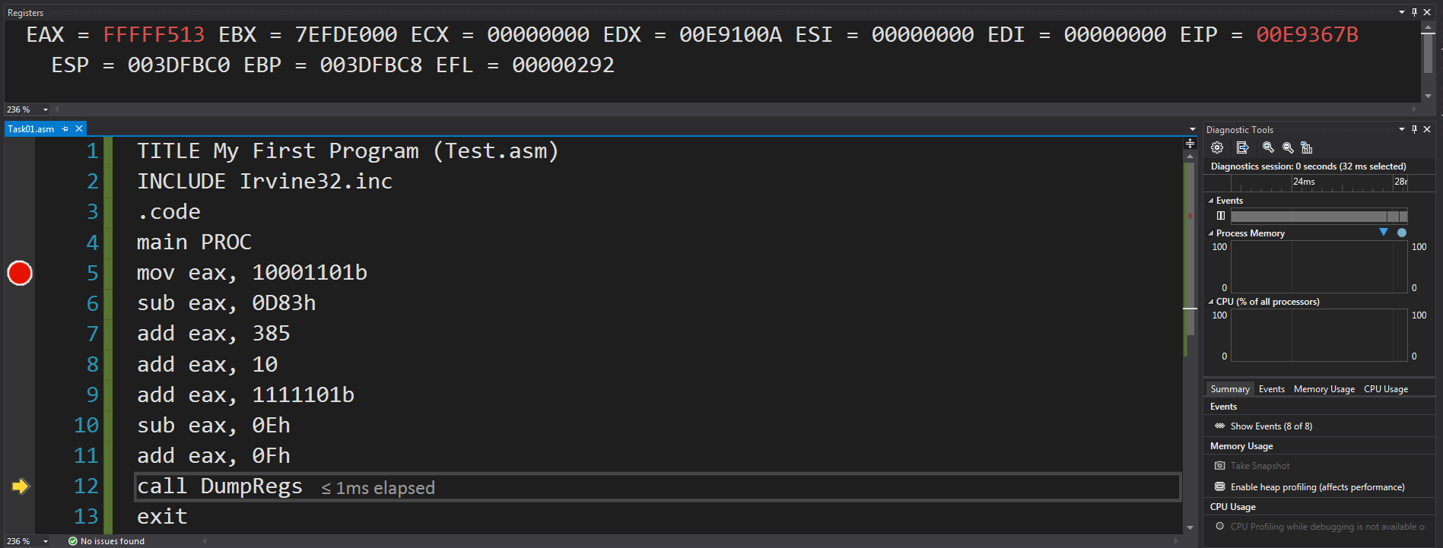

OUTPUT

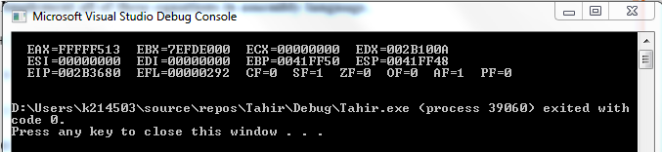

Code#05

DEBUG

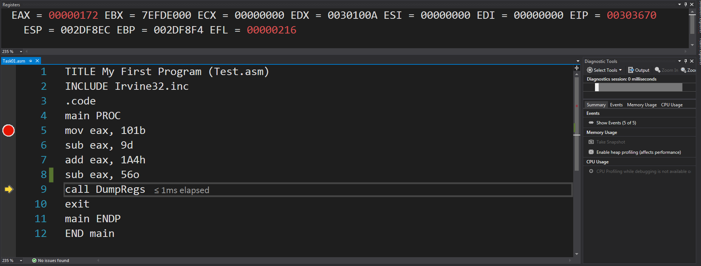

OUTPUT

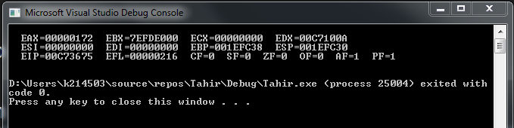

Code#06

Debug

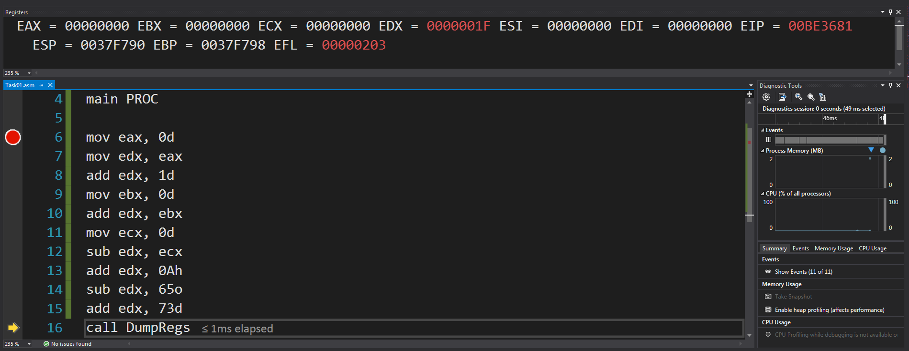

Ouput

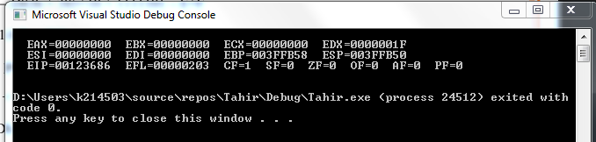

Code #07

Debug

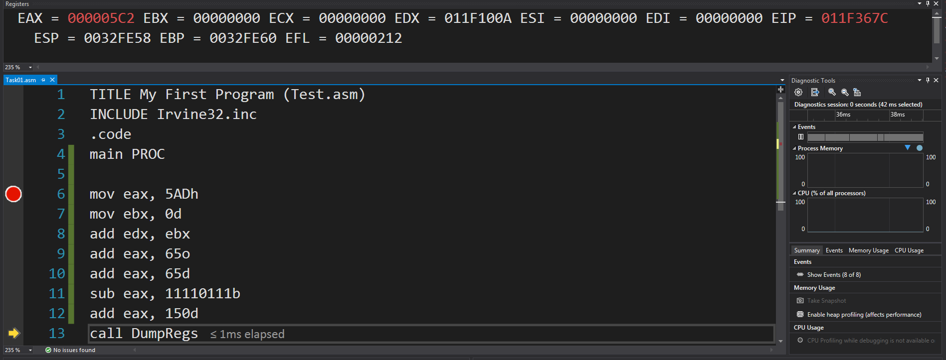

Ouput

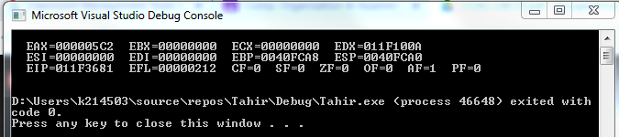

Code#08

DEBUG

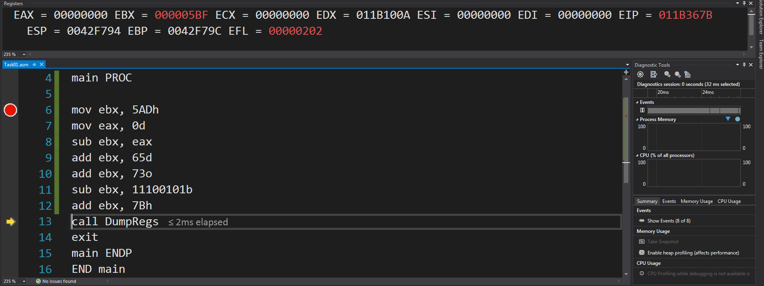

OUTPUT

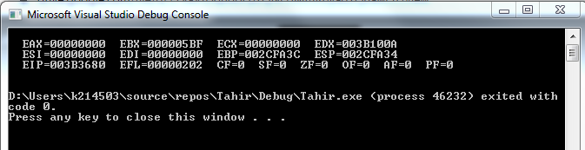

Code#09

Debug

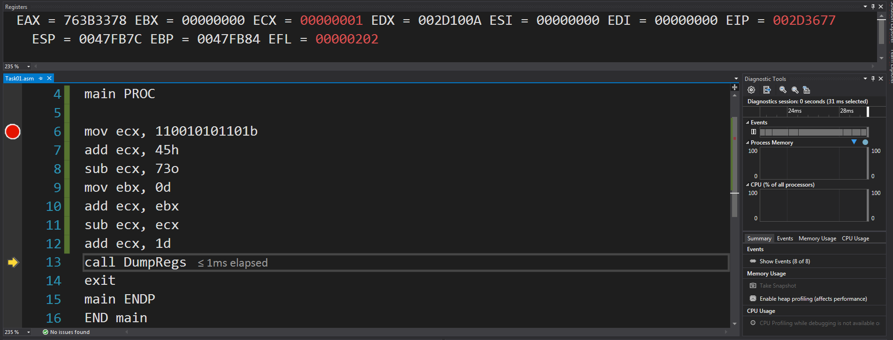

Output

